**DCRN Wallet Android Installation and Stake Tutorial**

Step 1: Open the website: <https://dcrn.xyz/wallet>

Step 2: Click Android and then click Install Wallet for Android to download the DCRN wallet for Android

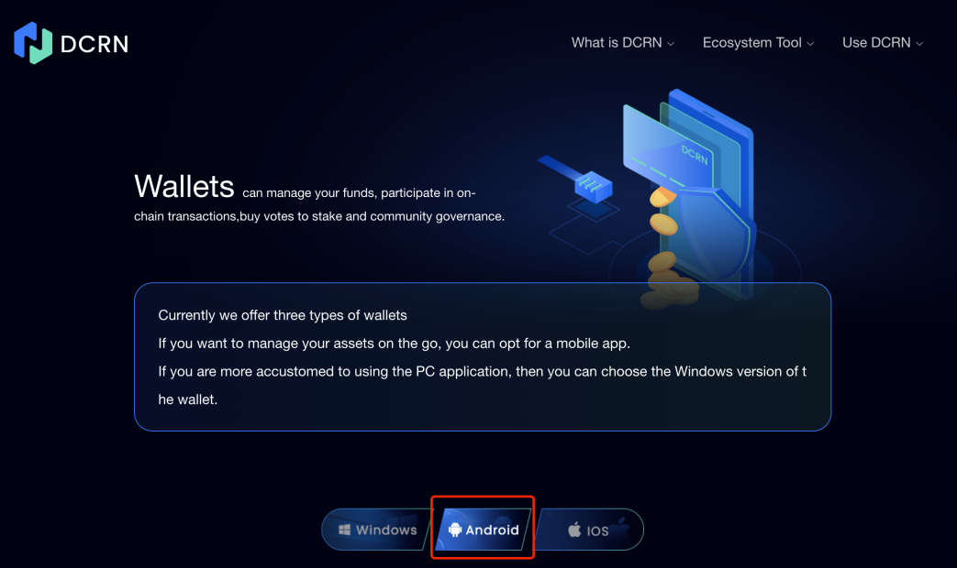

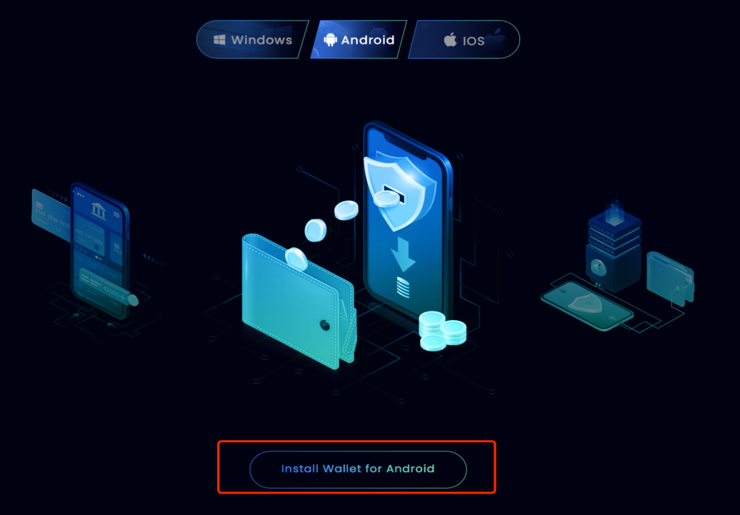

Step 3: Open the DCRN Wallet and click Create a new wallet

If you already have a DCRN Wallet, you can click Restore an existing wallet

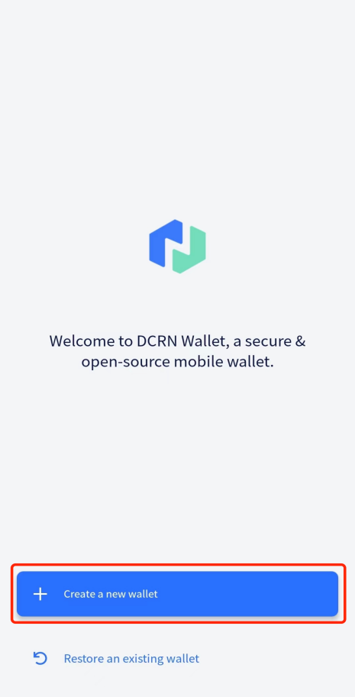

Step 4: Click Create after setting the password

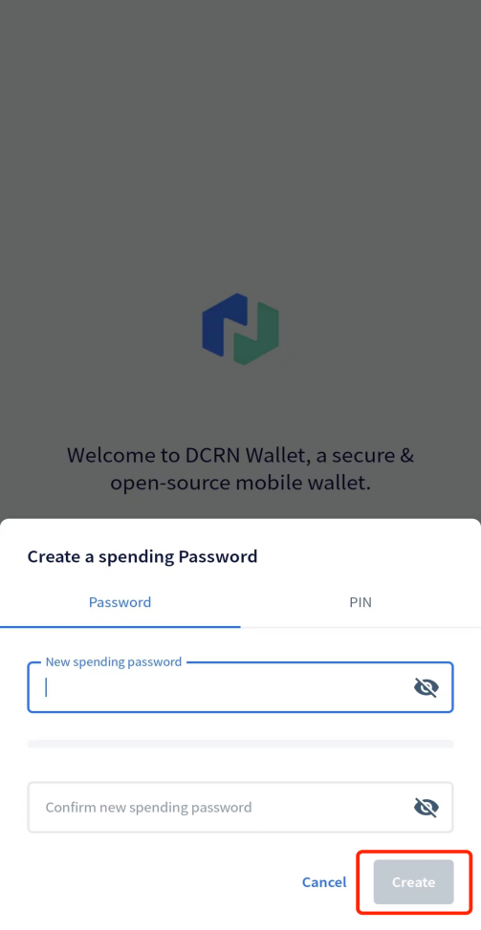

Step 5: Click Go to Wallet→Back up seed words, follow the steps to save and verify the seed words, then DCRN Wallet creation is complete.

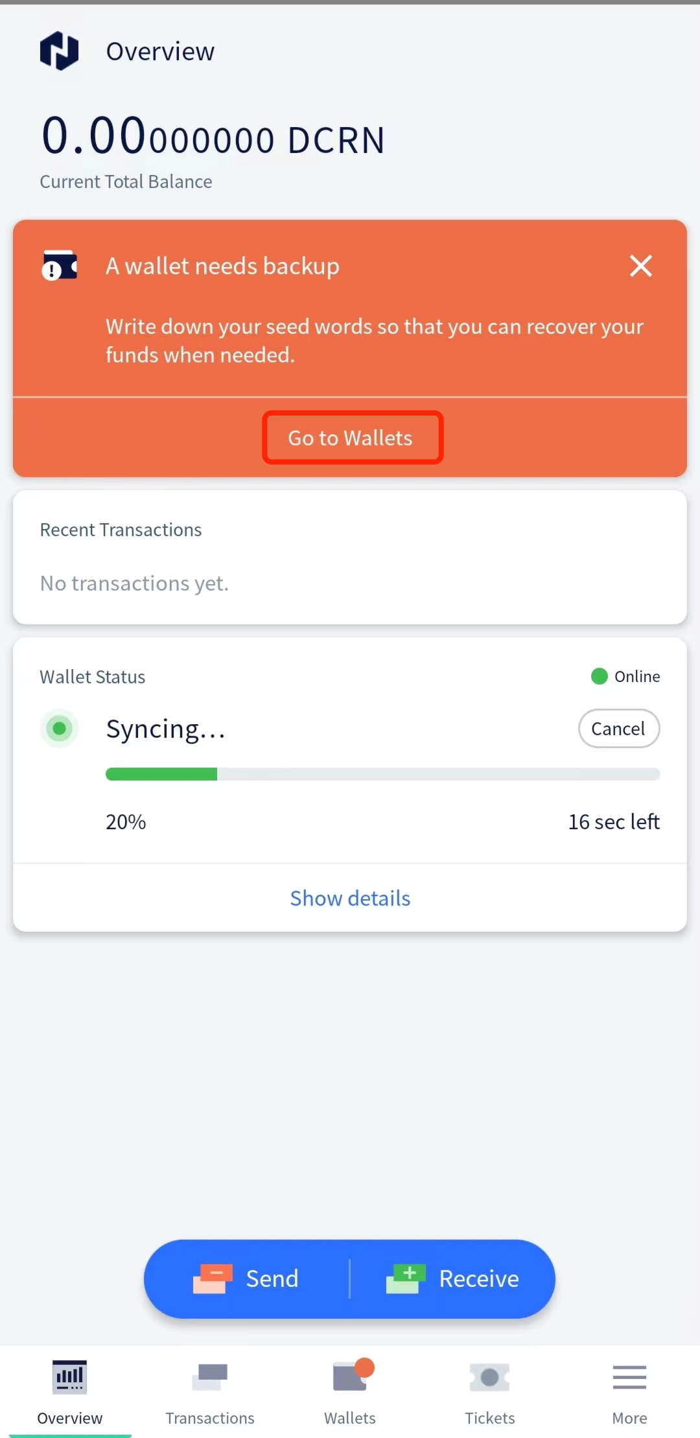

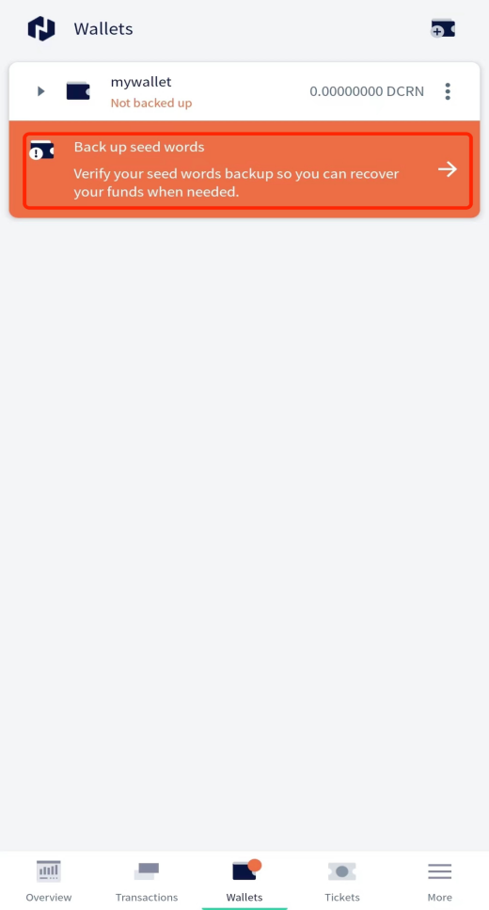

Step 6: Open the website: <https://dcrn.xyz/stake> , and click on link

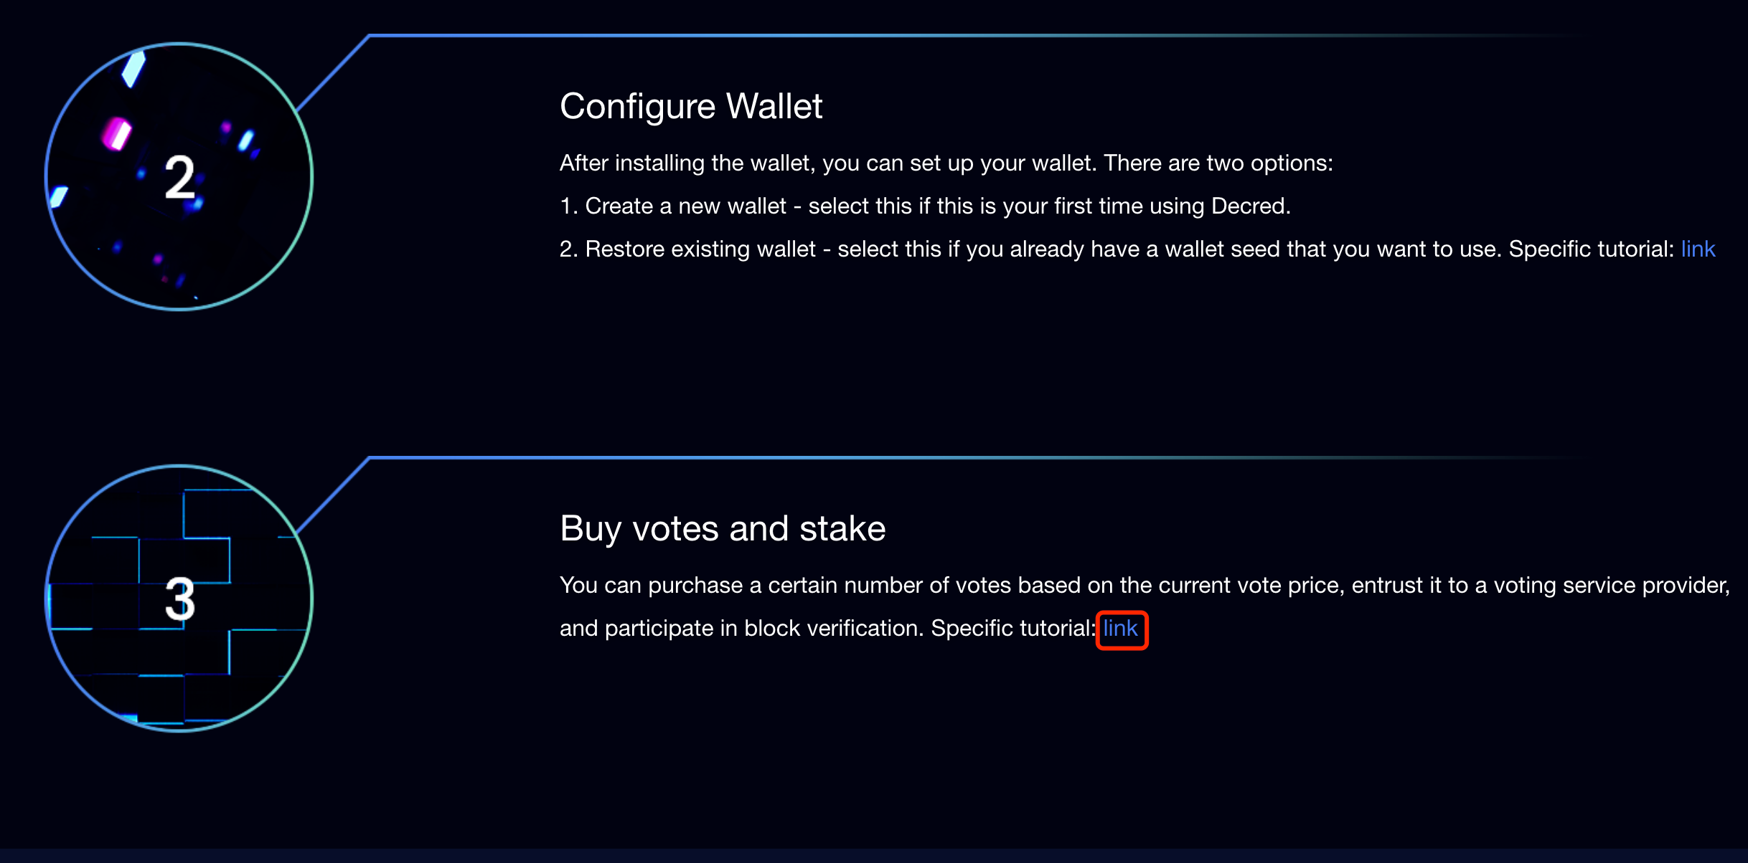

Step 7: Click VSP1 Address



Step 8: Click Register to register your account

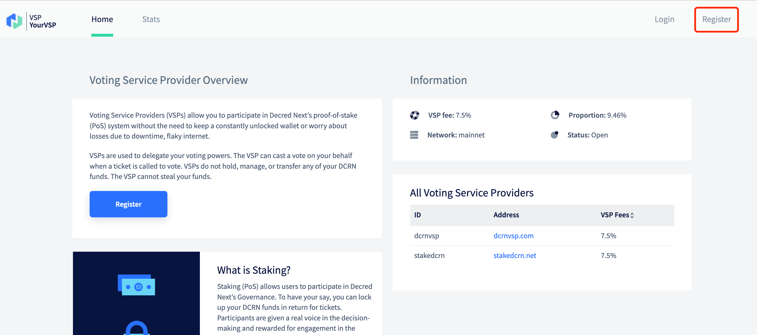

Step 9: Login after registration and click Connect to Wallet to get the API KEY

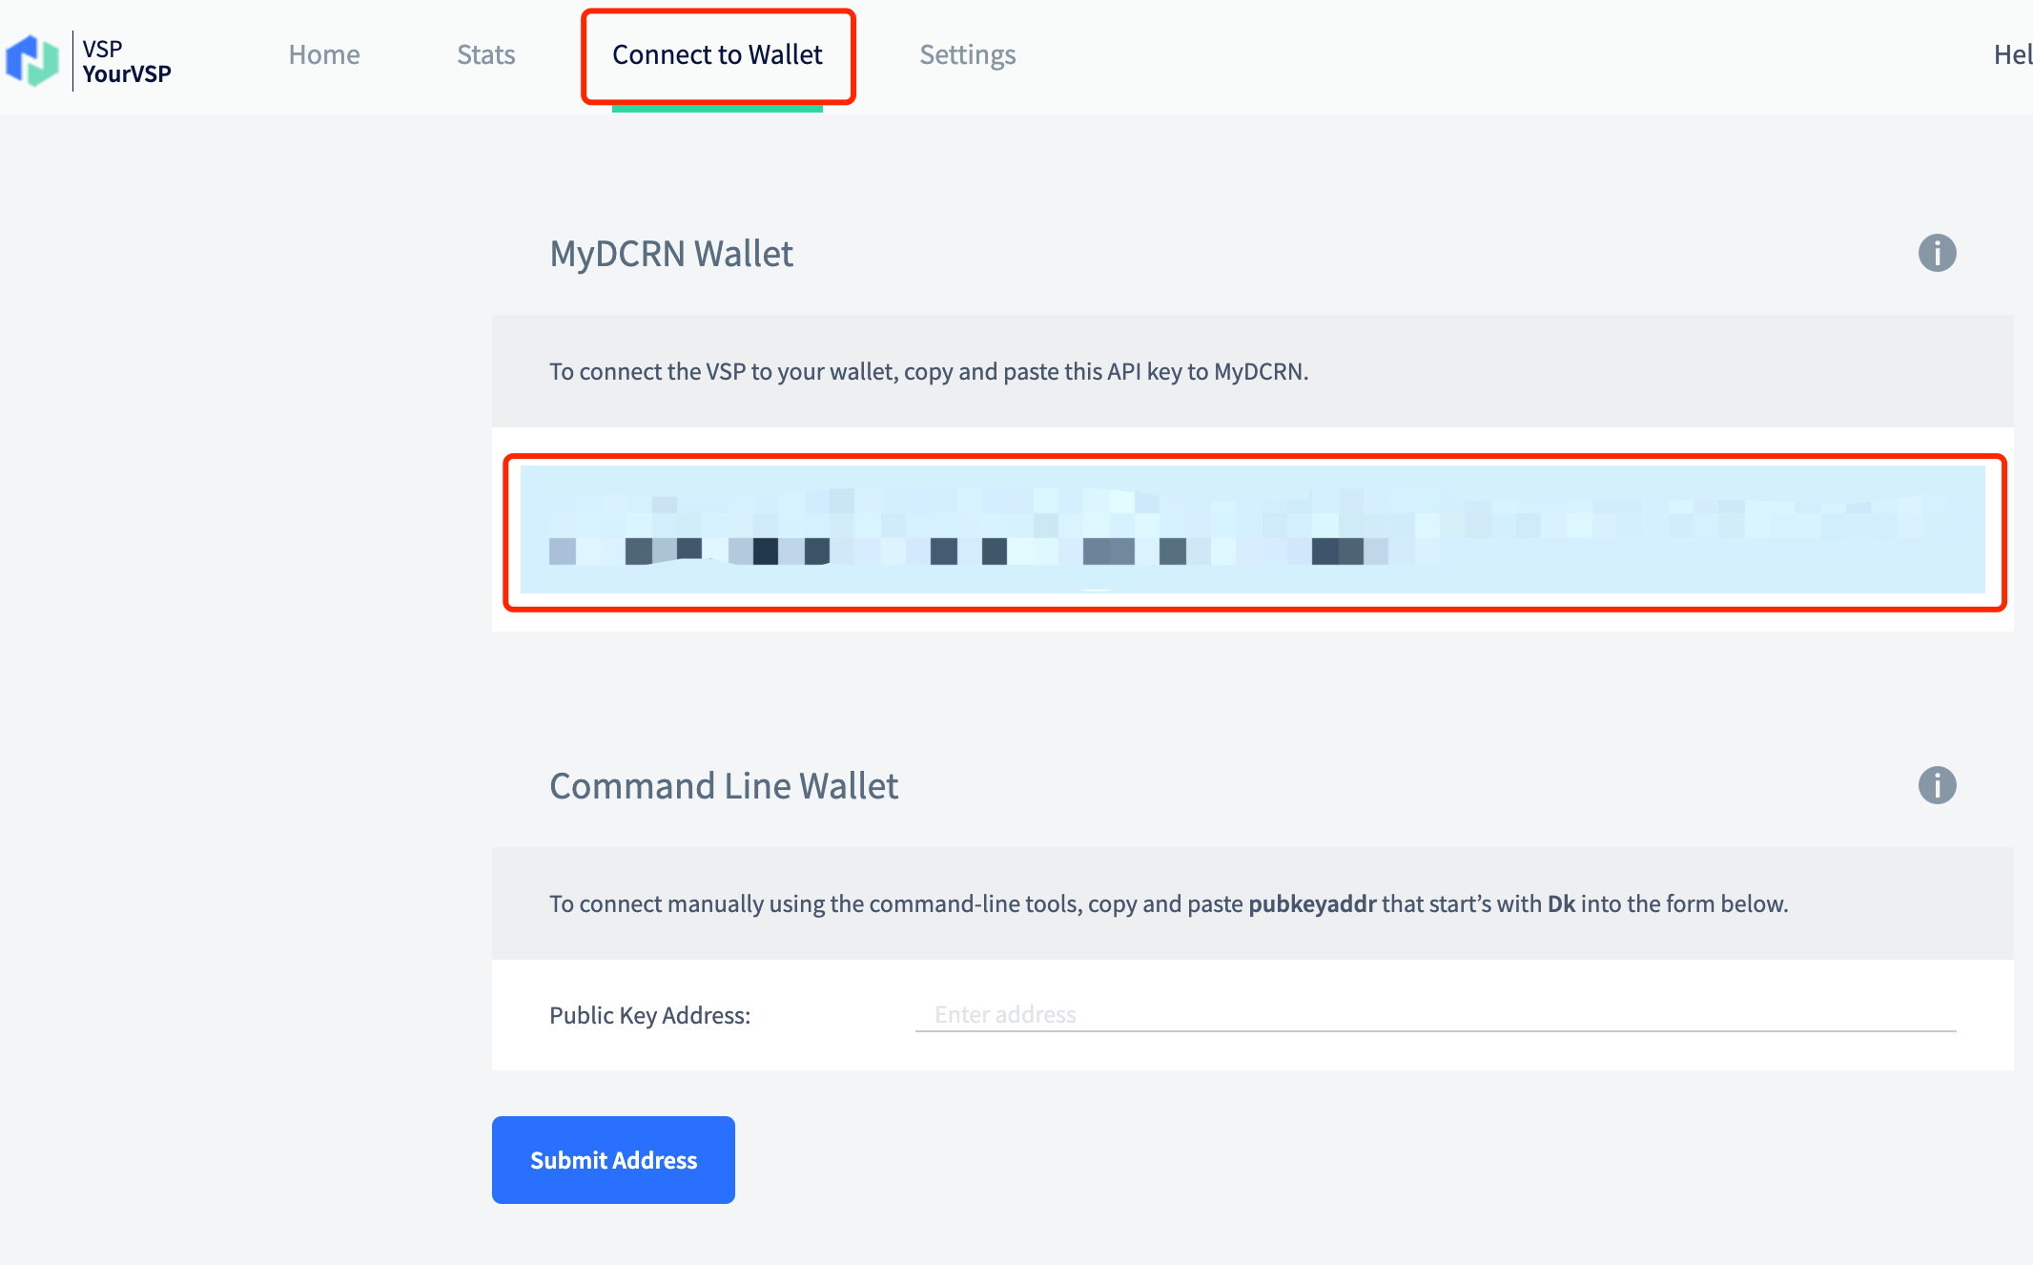

Step 10: Open DCRN Wallet and click Tickets→Add a VSP

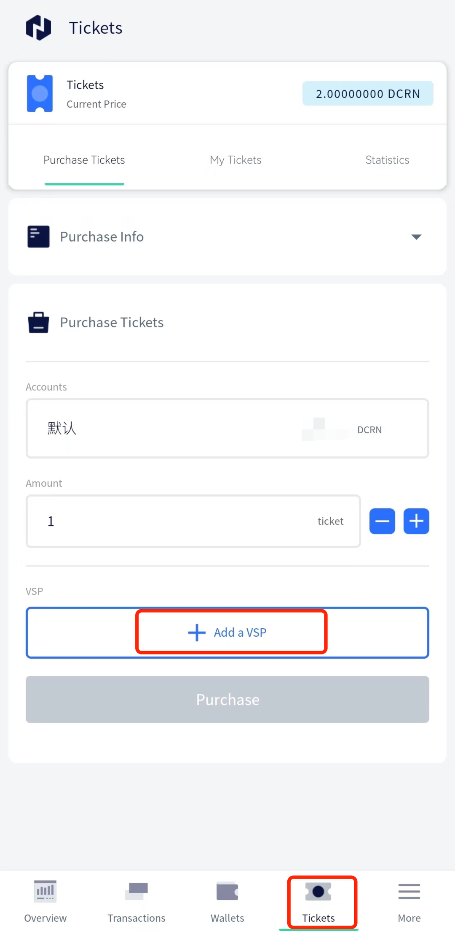

Step 11: Paste the obtained API KEY and click Continue to finish Add a VSP

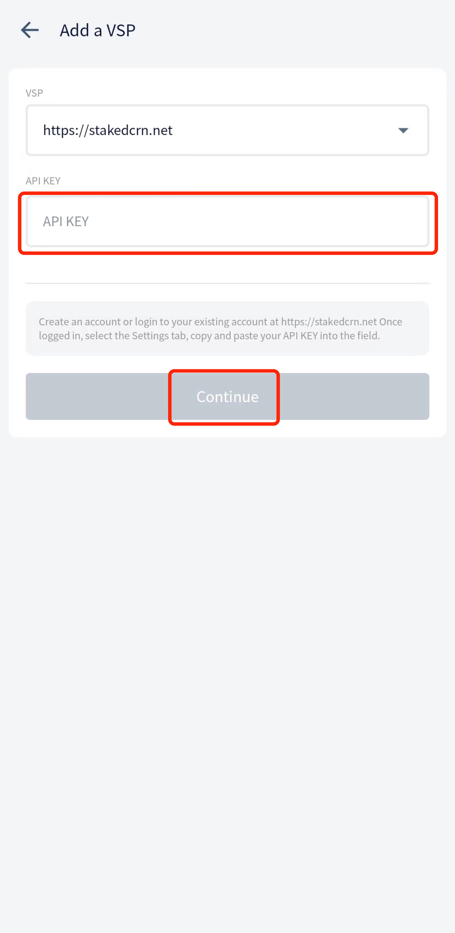

Step 12: You can purchase Tickets based on the DCRN balance to complete the Stake

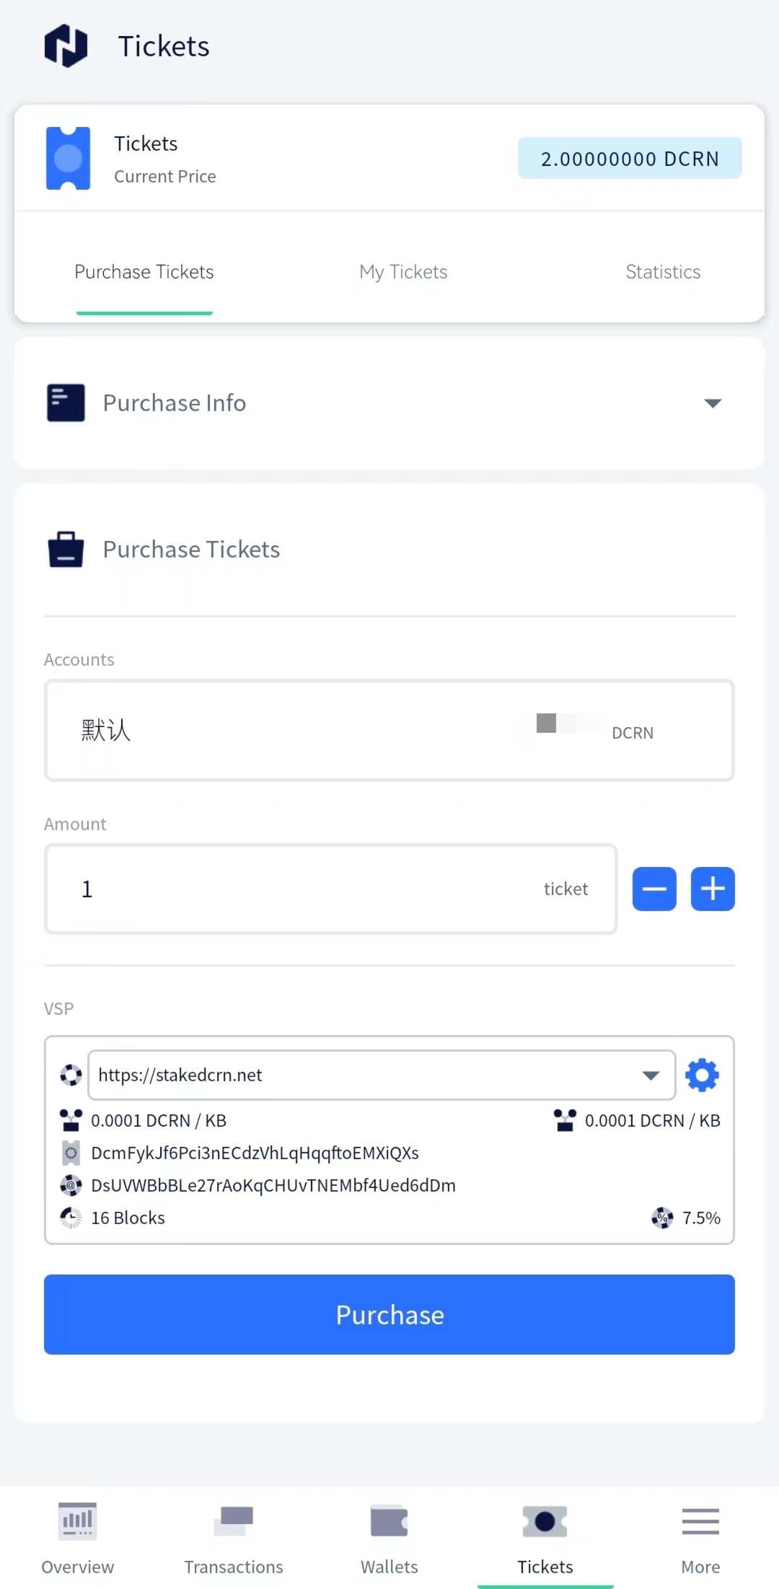

Step 13: Click My Tickets to view the purchased Tickets

